Plasma/Electrode Interactions in Plasma
Propulsion and High Current Density
Environments

Interim Report
September 10, 2012

Materials and Processes Far from Equilibrium Program
BAA- AFOSR-2011-04

PI: Prof. Edgar Choueiri
Electric Propulsion and Plasma Dynamics Lab (EPPDyL)
Applied Physics Group MAE Dept.
PRINCETON UNIVERSITY
Princeton NJ 08544
Phone: (609) 258 5220 Fax: (609) 258 6875
E-mail: choueiri@princeton.edu

Co-I: Dr. James E. Polk (JPL)
Collaborator: Dr. Alp Sehirlioglu (Case Western Reserve University)
1. Introduction.

This five-year research project will lead to the first systematic and comprehensive understanding of the plasma/electrode interaction (PEI) problems that are critical for meeting the projected requirements for high current density plasma-based devices of interest to the Air Force and DoD over the next three decades (with focus on the cathodes in plasma thrusters as the most demanding application). The approach consists of a set of related analytical, numerical and experimental tasks that are coordinated between three propulsion and material science groups and leverages existing state-of-the-art facilities and advanced diagnostics. Objectives include characterizing how the properties of electrode materials evolve in the hollow cathode environment, deriving accurate transport/surface kinetics models for both dispenser and bulk cathodes, and developing cathode design tools that will allow us to control the emitting area and recycling of evaporated material in the design of next generation high current cathodes. The research in the first year concentrates on lanthanum hexaboride cathodes.
In addition, we are investigating a number of high-risk revolutionary cathode concepts (using recent advances in RF and magnetic field plasma control), that are capable of meeting the requirements of long-lifetime operation in high current density plasma-based devices. The initial focus is on an RF-controlled hollow cathode.

2. Objectives.

The overarching objectives of this project are to:
1. Obtain the first systematic and comprehensive understanding of the plasma/electrode interaction (PEI) problems that are critical for the evolution of high current density plasma-based devices of interest to the Air Force over the next three decades (with focus on the cathodes in plasma thrusters as the most demanding application).

2. Use the resulting understanding to derive accurate transport/surface kinetics models and use them to develop cathode design tools.

3. Use the resulting design tools, our extensive state-of-the-art facilities and diagnostics, and our decades-long experience in the field, to develop and demonstrate a new generation of advanced hollow cathodes, as well investigate a number of high-risk revolutionary cathode concepts, that are capable of meeting the requirements of long-lifetime operation in high current density plasma-based devices.

The above objectives entail the following tasks and sub-tasks:

1. Understand how plasmas modify electrode surfaces:
a. Characterize LaB6 surface composition when exposed to plasmas carrying high current densities.
b. Measure the work function of low-work function materials.
c. Characterize mixed metal matrix cathodes.
2. Develop models and design tools:
a. Develop and validate dispenser cathode design tools.
b. Develop and validate LaB6 transport/surface kinetics model.
c. Develop and validate mixed metal matrix transport/surface kinetics model.
3. Engineer and test advanced cathodes in relevant testbeds:
a. Demonstrate the viability of a new generation of advanced hollow cathodes.
b. Demonstrate the viability of at least three high-risk revolutionary cathode concepts: the RF-Controlled hollow cathode, the magnetically choked cathode, and the liquid cathode.

3. Background.

In light of recent advances in space power generation, projections for near- to mid-term propulsion capabilities that would meet the spacecraft maneuvering requirements for the Air Force and DoD indicate the need for electric thrusters capable of processing larger amounts of power (100 - 200 kW) [1], well above the .5-12~kW range that has been the focus of electric propulsion development at the Air Force over the past two decades. At the moderate Isp of interest for thrusters at these power levels, the required discharge currents will be from 330 to 660 A, one to two orders of magnitude higher than that demanded of state-of-the-art cathodes in existing Hall thrusters. Since electrodes, and specifically cathodes, are the most highly stressed components of these high current density devices, there is a pressing need to solve a number of research problems that are critical to meeting these projected high-power and high-current requirements.

Cathodes used in electric thrusters are based on thermionic emitters developed for vacuum tube applications. However, the plasma in gas discharges fundamentally alters the operation of these cathodes, so investigation of plasma electrode interactions is key to any attempt to understand and improve cathodes for electric propulsion applications. The opportunity presented by this AFOSR-BAA offers a unique chance to carry out for the first time an extensive and systematic study of the plasma-electrode interactions whose understanding is critical to improving the lifetime of cathodes in plasma devices with high current densities, such as plasma thrusters and compact pulsed power systems.

While the application we will refer to most is cathodes in plasma thrusters, many of the fundamental problems and solutions we are concerned with in this project are also directly relevant to anodes and high current devices other than plasma thrusters, such as compact pulsed power systems, high-density energy storage, and switching devices. The application to cathodes in plasma thrusters is generally the most demanding and will be used as the context of our discussion.

Thermionic emitters, in which electrons are given sufficient thermal energy to escape over the work function barrier at the surface, can be divided into two types:
dispenser cathodes and bulk emitter cathodes.
Dispenser cathodes rely on a sub-monolayer coverage of an electropositive element such as barium on a refractory metal substrate such as tungsten, or a more complex surface structure such as barium on oxygen on tungsten, to produce a low work function surface. The electropositive material is lost by evaporation and must be continually replenished (“dispensed”) from the cathode interior.
Bulk emitter cathodes use emitters in which the bulk material itself has a low work function and does not need the complex surface chemistry to effectively emit electrons. These cathodes, although simpler, generally do not have as low a work function as dispenser cathodes and therefore operate at higher temperatures.

State-of-the-art dispenser cathodes have demonstrated lifetimes of up to 30,000 hours [2] and LaB6 cathodes have been operated for up to 10,000 hours [3] with emitted currents of 5-15 A. However, the next generation of higher power thrusters of interest to the Air Force [1] will require cathodes capable of operating reliably for even longer periods of time at emission currents up to two orders of magnitude higher than state-of-the-art cathodes, placing tremendous stresses on cathode technology. The purpose of this program is to develop the fundamental physical understanding required to design and validate the next generation of high current cathodes and demonstrate how this understanding can be used to engineer a new generation of high-performance cathodes for high current density environments.

4. Critical Plasma/Electrode Interaction (PEI) Problems

There is currently no systematic design methodology for hollow cathodes. All existing cathodes were developed empirically over a 30 year period, with no clear understanding of many aspects of the physics that control cathode operating temperature, effective emitting area and lifetime. Plasma-material interactions at the emitter-plasma interface are at the root of the three critical challenges the community now faces.

Critical Problem 1: Understanding how interactions with the plasma fundamentally alter electrode surfaces. The hollow cathode plasma controls the operation of the electron emitter in two fundamental ways. First, the effective surface area for electron emission is determined to a large extent by the fraction of the emitter surface in contact with the plasma, because the plasma acts as the heat source maintaining the temperature of the thermionic emitter and serves as a low impedance path for the flow of electrons. In state-of-the-art cathodes the plasma is often confined to a narrow zone at the downstream end of the insert, limiting electron emission to a very small fraction of the emitter surface. The current density is therefore much larger than necessary, resulting in much higher operating temperatures and reduced cathode lifetime. This reflects the fact that existing cathodes were designed without an understanding of what the plasma contact area would be or how to control it.

Second, the plasma can have a major effect on the transport of material evaporated from the emitter surface. Two material properties drive cathode lifetime--the work function and the desorption rate of work function-lowering adsorbates such as barium on tungsten or the evaporation rate of the bulk material as in LaB6 emitters. These two properties are clearly coupled, as evaporation or desorption can change the work function. For instance, non-uniform evaporation of lanthanum and boron in LaB6 cathodes can result in surface stoichiometry and work function changes. In vacuum tube applications, material evaporated from the surface simply leaves. With an ambient plasma, however, the evaporation rate is affected by diffusion through the gas, and if the evaporated material becomes ionized in the plasma, the transport is largely controlled by the strong electric fields near the surface. The work function and evaporation rate are fundamentally altered by these processes. There is a critical need for the application of state-of-the-art surface analysis diagnostics to understand how the plasma alters the surface.

Critical Problem 2: Developing the ability to predict the effects of plasma-materials interactions that impact cathode lifetime. The understanding of plasma-materials interactions that comes from careful experimentation must be crystallized into predictive models that can then be applied to design problems. For example, considerable progress has been made recently in the understanding of barium transport in conventional dispenser hollow cathodes using this approach [4, 5, 3]. Modeling and experiments show that barium transport in dispenser hollow cathodes differs fundamentally from that in cathodes in vacuum devices. Research over the last four years has revealed key differences that control barium depletion in conventional hollow cathodes. The most important of these is that barium is very effectively recycled in the discharge. Barium supplied from the insert upstream of the electron emission zone is ionized in the high density xenon plasma and pushed down to the emitter by the electric field. Resupply through the gas phase by recycling compensates for the loss of vapor flow from the interior when the tungsten shell forms. Very little barium vapor is lost through the upstream or downstream cathode boundaries. The next step is to apply these modeling tools to the design of larger, higher current dispenser hollow cathodes to ensure that they exploit barium recycling effectively.

Because these phenomena have only recently been recognized, cathodes have never been engineered to optimize recycling of evaporated material. Similar processes undoubtedly also occur in LaB6 cathodes with comparably profound consequences on cathode life, and this is currently under investigation. A key objective of this work is to understand and model these processes in sufficient detail for both dispenser and bulk cathodes so that we can control the emitting area and recycling of evaporated material in the design of next generation high current cathodes.

Critical Problem 3: Engineering novel cathodes that exploit our understanding of contact area control and material transport processes. The lack of understanding of the plasma, surface chemistry, and mass transport processes in hollow cathodes has prevented development of real design tools. A primary challenge to be addressed in this program is the development and demonstration of novel new cathode designs with increased attachment area and optimized material recycling using design tools based on the fundamental research.

5. Overview of the Plasma-Electrode Interactions Program

This research includes three approaches that address the challenges identified in the previous section:

Approach 1. Application of state-of-the-art materials analysis tools. The materials aspect of this research focuses on bulk materials such as LaB6 and dispenser cathodes with additives such as rhenium, osmium and scandium. LaB6 offers lower evaporation rates for a given current density below about 15 A/cm² and greatly reduced sensitivity to contaminants. Combined with strategies to reduce the current density by increasing plasma contact area and further reduce evaporative losses by optimizing recycling, LaB6 has the potential for revolutionary improvements in cathode capability.

Mixed-metal matrix dispenser cathodes employ substrates such as tungsten-rhenium or tungsten-osmium alloys which reduce the work function to as low as 1.9 eV [3]. Work function reductions of this magnitude can extend cathode life by as much as a factor of two. Coatings of scandium on Ba-O with a tungsten substrate have been found to yield work functions as low as 1.7 eV, resulting in temperature reductions of hundreds of degrees. Dispenser cathodes incorporating scandate materials may exhibit reductions in work function similar to those in vacuum cathodes with scandate coatings. This is a high risk approach because the mechanism for this reduction is not well-understood, but would have an enormous payoff in terms of cathode lifetime if these temperature reductions can be realized.

State-of-the-art surface diagnostics will be employed to elucidate the erosion processes in LaB6 and mixed-metal matrix cathodes and determine how plasma transport processes impact the surface stoichiometry and therefore the work function. The data from these measurements will be used to help guide the development and validation of plasma transport models.

Approach 2. Application of state-of-the-art materials transport and surface kinetics modeling tools. To address the challenge of understanding the plasma's effect on the transport of erosion products, we are employing the same approach that was so successful in revealing similar dynamics in conventional dispenser hollow cathodes [4, 5]. The transport model developed for dispenser cathodes describes the flow of barium neutrals and ions in a background xenon plasma. We are modifying this to model the transport of lanthanum and boron evaporated from the emitter surface of LaB6 cathodes and refractory metal transport in advanced mixed metal matrix dispenser cathodes.

These models are being developed in parallel with the surface chemistry measurements described in approach 1. Preliminary results of the modeling will be used to define the experiments needed. The experiments will provide refined input data for the modeling and will ultimately be used to validate aspects of the models. The results of the transport and surface kinetics models will be used to determine the steady-state surface chemistry and work function, as well as the net evaporation rate that determines cathode life. Ultimately these models will be used as unique design tools, allowing LaB6 and mixed metal matrix cathodes to be optimized for long life.

Approach 3: Experimental Demonstrations. This research is ultimately driven by the need for very long life, high current cathodes. Once the design tools are validated, we will design, fabricate and test optimized hollow cathodes. This will involve choosing the best emitter material and selecting the hollow cathode geometry that yields a large emitting area and creates the conditions for effective recycling.

In addition to applying the tools we develop to optimize hollow cathodes with a more conventional design, we are exploring high-risk but potentially high-payoff solutions. Among these are the following radical concepts in cathode design, based on distilling our decades-long experience in electric propulsion, that allow increasing and controlling the current attachment dynamics. These approaches involve applying additional RF power to extend the plasma volume in contact with the emitter surface and using magnetic fields to control the attachment area. We will also explore a concept that relies on attaching the current on liquid metals for applications where the use of such materials will be allowable (e.g. when the same liquid metals are used as propellant). The plasma/liquid metal interface opens up a new dimension in current attachment control that has not been explored much before. We will study both passive methods (e.g. liquid evaporation, dynamic self-adjustment of emission area) and active control (e.g. magnetic constriction and enlargement of the attachment areas) to explore the feasibility of such novel cathodes.
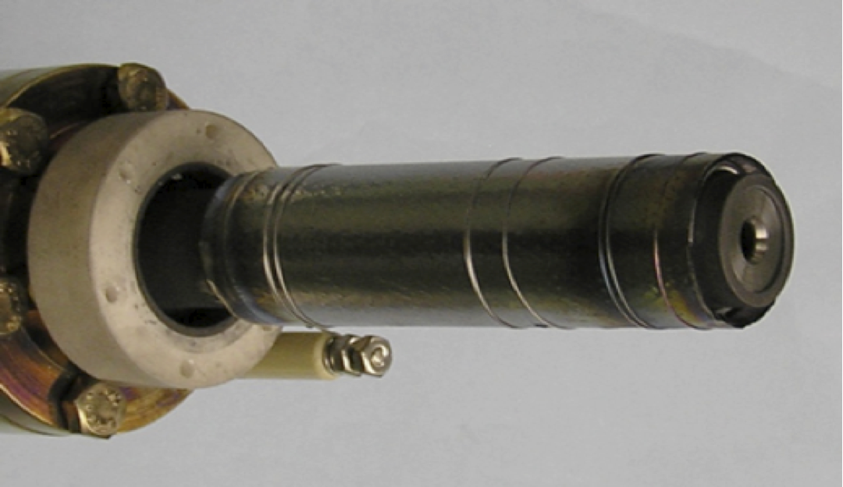

Figure 1: 1.5 cm diameter LaB6 hollow cathode

6. Recent Progress in LaB6 Cathode Transport Modeling.

As noted above, the plasma plays a key role in determining the transport of erosion products from the emitter surface (which ultimately determines cathode life) and the chemical state of the emitter surface (which determines work function, and therefore operating temperature. We are pursuing a combination of modeling and experiments to understand these processes. Here we report on recent progress in modeling the transport of La and B in the xenon plasma of a LaB6 hollow cathode designed to operate at up 100 A. Figure 1 shows the cathode, which consists of a 1.27 cm diameter, 2.5 cm long LaB6 insert in a 1.5 cm diameter cathode tube. The tube is surrounded by a high temperature heater used to preheat the cathode

The hollow cathode plasma code OrCa2D, developed at JPL, was used to model the xenon plasma in the interior of the 1.5 cm diameter LaB6 cathode. The results displayed in Figure 2 show that the plasma density peaks on centerline about 1 cm upstream of the orifice, while the electron temperature peaks at the orifice. The plasma potential also peaks in the orifice, reflecting an internal electric field which points upstream and radially outward toward the emitter surface.
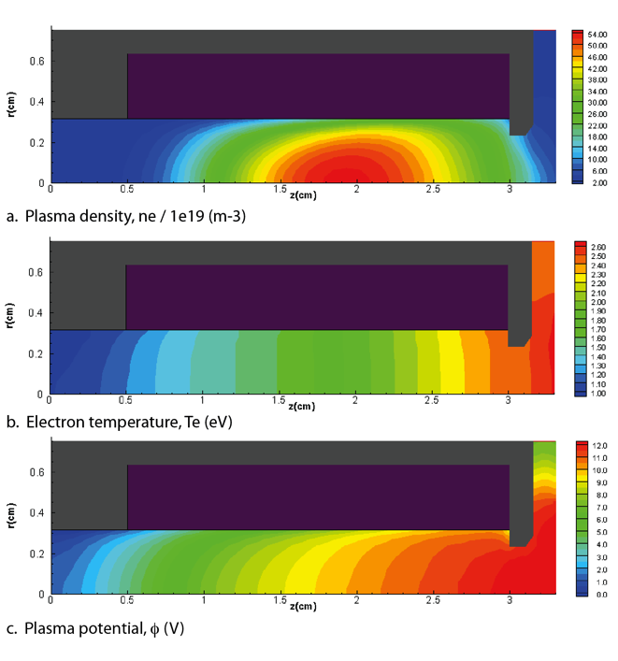
Figure 2: Results of xenon plasma simulation of the 1.5 cm diameter LaB6 cathode operating at 50 A.

Analytical models of the boron and lanthanum ionization cross sections were used to compute the ionization rate coefficients. The ionization frequency, which depends on electron density and temperature, was then calculated and used with the B and La atom thermal velocities to determine the ionization mean free paths. As show in Figure 3, the lanthanum ionization mean free path is on the order of 200 micrometers near the entrance to the orifice. In contrast, the boron mean free path is on the order of several mm near the exit, reflecting the higher ionization potential (8.3 eV vs. 5.58 for La). As a result, La atoms evaporated from the surface are very likely to be ionized and drawn back to the surface by the electric field, while the majority of the B atoms will remain neutral and escape through the cathode orifice. The detailed dynamics of La and B transport are currently being studied with the transport model, but these qualitative results show that recycling of La will result in a La-rich emitter surface.
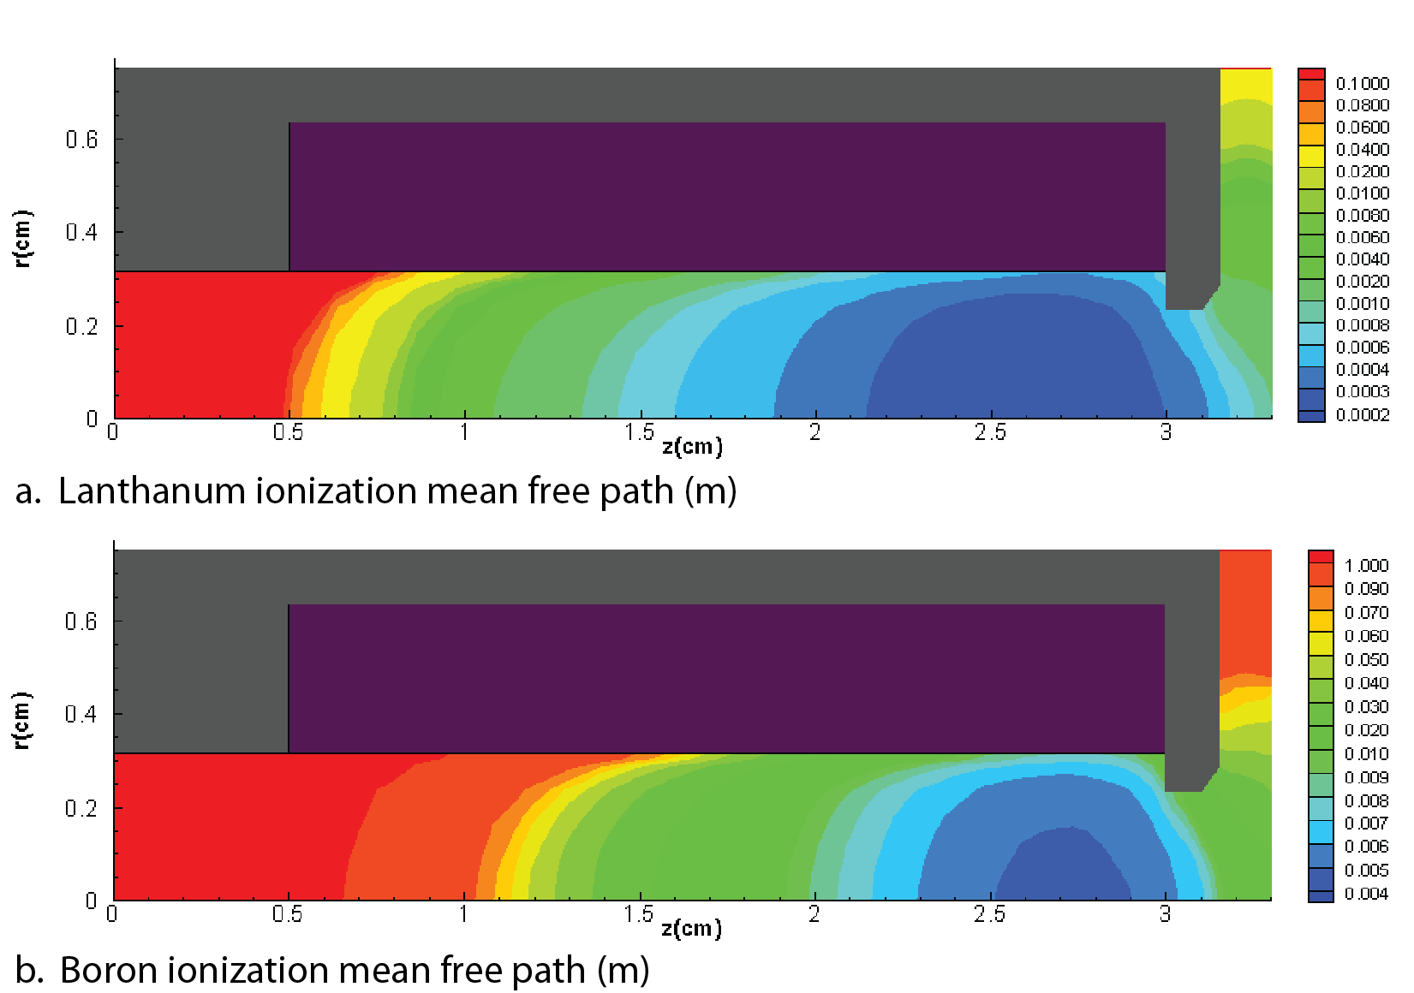

Figure 3: Ionization mean free paths for lanthanum and boron in the hollow cathode insert plasma.

These results are being used to define the requirements for the materials science program. Key findings so far indicate that the surface science investigations must focus on the equilibrium surface stoichiometry of a LaB6 (bulk stoichiometry) material as a function of the La flux from the plasma, the work function of the resulting surface chemical state, and the net erosion rate.

7. Recent Progress in RF-Controlled Hollow Cathode Technologies.

In addition to the LaB6 cathode modeling, we explored a novel RF-Controlled Hollow Cathode (RF-CHC) concept using finite element analysis. We used commercial software to model the extent of RF power absorption in one configuration of such a cathode in order to describe whether the RF power is localized as in a ``stinger'' concept, where absorption occurs near a conducting probe-like device to provide a localized plasma in regions of interest, or whether substantial RF power is projected downstream to control the plasma-emitter attachment area. For high current density hollow cathodes operating in a regime where the plasma density falls off and the emission becomes space-charge limited at some upstream location along the emitter insert (depicted in Figure 4), broadening the plasma attachment will enlarge the emission area and thus reduce current density at a constant discharge current. By decreasing the current density peak and increasing the plasma attachment area at a constant discharge current, we expect an increased emitter lifetime and maximum discharge current [6].

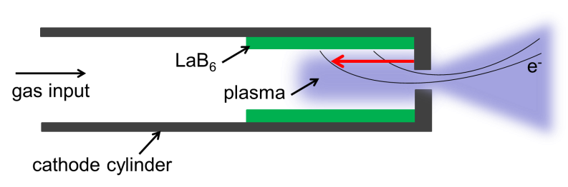
The lanthanum hexaboride (LaB₆) cathodes designed and tested by Goebel and Chu [7] were built for high current and tested up to 250 A. We selected their 1.5 cm diameter cathode as a baseline for our analysis.
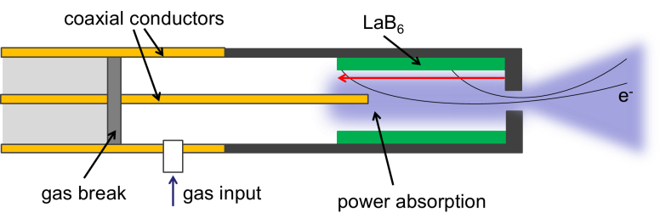
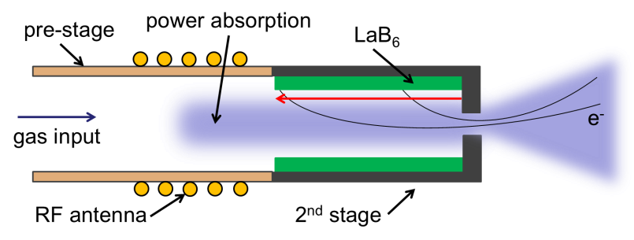
Two configurations of the RF-CHC concept were considered and one configuration was analyzed. A two-stage configuration relies on adding an RF energy pre-stage to the standard LaB₆ cathode, shown in Figure 5. An RF antenna would encircle a pre-stage section made of a dielectric, like ceramic. A dielectric pre-stage would allow the RF waves to pass through ceramic cylinder while maintaining a high temperature barrier between the internal plasma and the antenna.
Figure 5: Two-stage RF-controlled hollow cathode.
Figure 4: Conventional hollow cathode.

Another configuration of the RF-CHC, depicted in Figure 6, is a single-stage device where RF waves of higher frequencies (1-40 GHz range), or microwaves, are injected upstream of the cathode and intended to propagate downstream, along the cathode major axis to the plasma attachment region. This configuration mates the upstream end of the cathode to a microwave source via a waveguide and effectively treats the conductive cathode cylinder as a cylindrical waveguide. The single-stage configuration has the advantages of minimal input-power loss and greater parameter flexibility compared to the two-stage configuration. We chose the coaxial single-stage configuration with a common 2.45 GHz microwave frequency to be the focus of our analysis.
Figure 6: Single-stage RF-controlled hollow cathode.

We calculated a plasma conductivity profile along the major axis from the baseline hollow cathode [7] parameters. The internal cathode cavity was split into four discrete, solid three-dimensional volumes, shown two-dimensionally in Figure 7, and each was assigned an average plasma conductivity to approximate the calculated conductivity profile. We found that this four-volume model captured the essential RF absorption behavior.

We used finite element analysis with COMSOL Multiphysics® v3.5a to model the electric field magnitude shown in Figure 8. Scattering parameters provided by the model allowed us to calculate the absorbed RF power as a function of distance, shown in Figure 9.
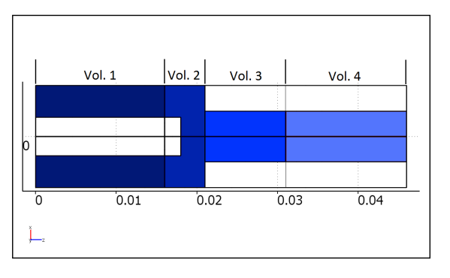
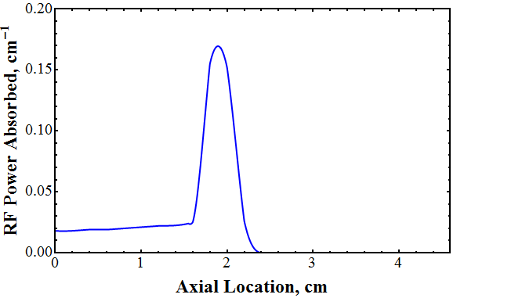
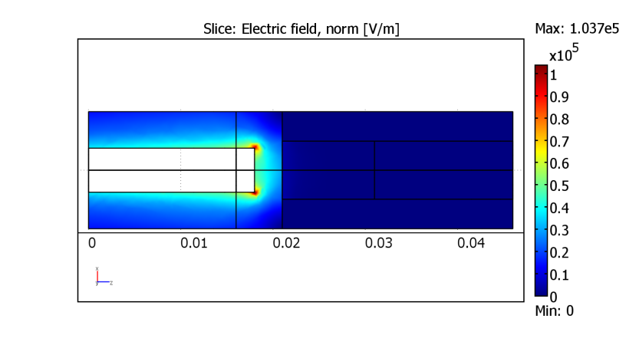
The location of highest electric field magnitude at the inner conductor tip, shown in Figure 8, is also where the majority of the RF absorption takes place, as per Figure 9. We found that within a maximum axial distance from the orifice, a direct coaxial-cathode mating can lead to high percentages (>96%) of localized microwave power absorption. The single-stage configuration analyzed acted as a stinger, as approximately 62% of the RF power was absorbed within 2 mm of the inner coaxial conductor tip, providing localized RF power absorption.
Figure 8: Electric field distribution in the insert region.
Figure 7: RF cathode model domains.
Figure 9: Power deposition profile.

Our modeling of a negligible conductivity, single-volume model suggests that the RF source could break down xenon gas at the conductor tip and start cathode emission or play an assisting role to the cathode keeper voltage. The negligible conductivity model results in an electric field magnitude appearing the same as Figure 8. We also examined RF heating of the emitter prior to plasma ignition, but low RF power absorption (<5%) without a lossy plasma suggests poor feasibility of this function.

The numerical analysis presented here could be refined, including refinement by use of higher fidelity plasma simulations such as those conducted by Polk, et al., on dispenser cathodes [4,5]. Theoretical modeling and experimental testing are of interest for future work. As with most new concepts, there is a large parameter space to explore, including cathode and insert geometries, methods of RF coupling with the cathode internal plasma, and axial location of RF input power. In light of these preliminary results, we find that the RF-CHC concept can be a localized source of RF power absorption as modeled, and other RF-CHC configurations to be explored hold the potential to decrease current density at constant discharge current via RF power projection and significant absorption downstream.

8. Conclusions.

The FY12 activities are advancing the state-of-the-art in high current LaB6 cathodes and advanced concepts such as RF-controlled hollow cathodes. The results indicate that La will be effectively recycled in hollow cathodes that are properly configured to produce a dense, high temperature xenon plasma combined with strong electric fields, and that RF power can be effectively deposited upstream of an electron emitter. Current work is focused on detailed La and B transport modeling, defining supporting surface measurements, improved modeling of the RF-controlled cathode concept, and experimentally demonstrating RF-controlled cathodes.

9. References.

[1] D.L. Brown, B.E. Beal, and J.M. Haas. Air Force Research Laboratory high power electric propulsion technology development. In IEEE 2010 Aerospace Conference, Big Sky, MT, 2010. 10.1109/AERO.2010.5447035.

[2] A. Sengupta, J.R. Brophy, and K.D. Goodfellow. Status of the Extended Life Test of the DS1 Flight Spare Ion Engine after 30,352 Hours of Operation. In 40th Joint Propulsion Conference, Fort Lauderdale, FL, 2004. AIAA-2004-4558.

[3] D.M. Goebel and I. Katz. Fundamentals of Electric Propulsion: Ion and Hall Thrusters. JPL Space Science and Technology Book Series. JohnWiley and Sons, Pasadena, 2009.

[4] J. E. Polk, I. G. Mikellides, I. Katz, and A. M. Capece, “Tungsten and Barium Transport in the Internal Plasma of Hollow Cathodes,” Journal of Applied Physics, vol. 105, no. 11, p. 113301, 2009.

[5] J. E. Polk, A. M. Capece, I. G. Mikellides, and I. Katz, “Barium Depletion in the NSTAR Discharge Cathode After 30,472 Hours of Operation,” in 46th Joint Propulsion Conference, 2010.

[6] D. M. Goebel, K. K. Jameson, and R. R. Hofer, “Hall Thruster Cathode Flow Impact on Coupling Voltage and Cathode Life,” Journal of Propulsion and Power, vol. 28, no. 2, pp. 355–363, Mar. 2012.

[7] D. M. Goebel and E. Chu, “High Current Lanthanum Hexaboride Hollow Cathodes for High Power Hall Thrusters,” in 32nd International Electric Propulsion Conference, 2011, pp. 1–16.

